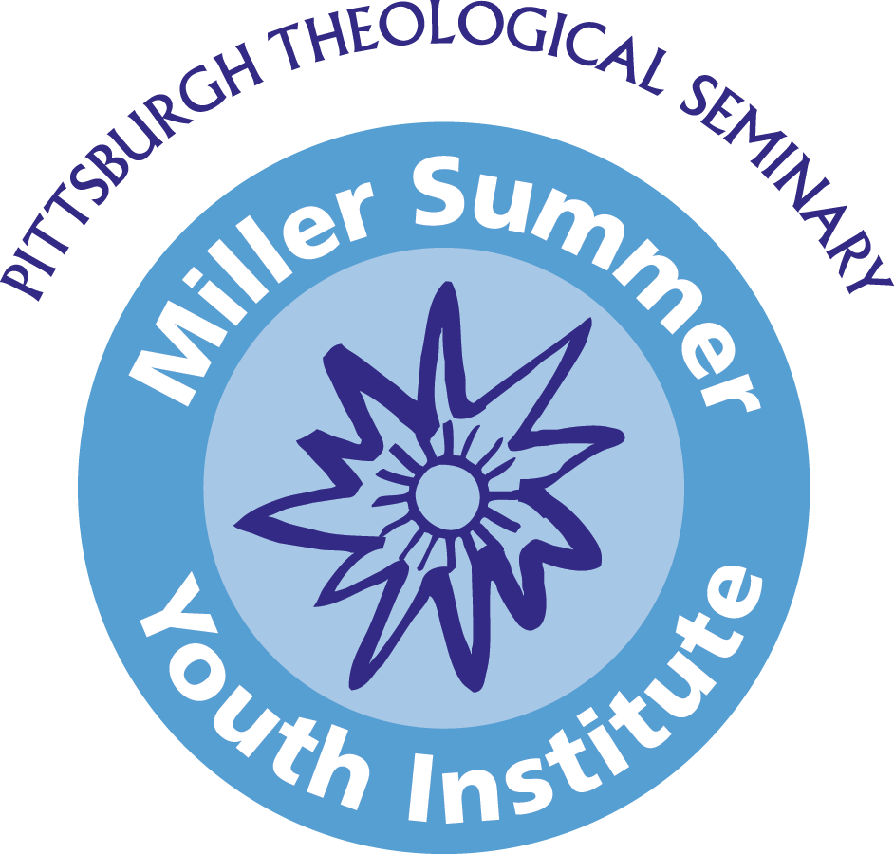
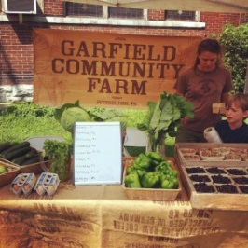

Schedule 2020
Saturday
Travel Day

Sunday
“Orientation”
9:00-9:30am Breakfast in Calian Hall First Floor Lounge
9:45-10:00am Walk to Worship at local church
10:00-11:30 a.m. Worship at local church
12:00-2:00pm Lunch/Free Time
2:00-5:30pm Orientation with SYI
5:30-6:30pm Dinner provided by group
6:30pm Evening to Explore PGH

Monday
“Service Day 1”
8:00-8:20am Breakfast in Dining Hall- pick up bagged lunches
8:20am Morning Devotions – dining hall
8:45am Depart for mission sites
8:45am-4:00pm Open Hand Ministries/Garfield Farm
4:00-5:00pm Free Time
5:00-6:00pm Dinner provided by group
6:30pm Evening to Explore PGH

Tuesday
“Service Day 2”
8:00-8:20am Breakfast in Dining Hall- pick up bagged lunches
8:20am Morning Devotions – dining hall
8:45am Depart for mission sites
8:45am-4:00pm Open Hand Ministries/Garfield Farm
4:00-5:00pm Free Time
5:00-6:00pm Dinner provided by group
6:30pm Evening to Explore PGH

Wednesday
“Service Day 3”
8:00-8:20am Breakfast in Dining Hall- pick up bagged lunches
8:20am Morning Devotions – dining hall
8:45am Depart for mission sites
8:45am-4:00pm Open Hand Ministries/Garfield Farm
4:00-5:00pm Free Time
5:00-6:00pm Dinner provided by group
7:00-8:00pm Taize Worship at East Liberty Presbyterian Church

Thursday
“Service Day 4 and Speaker day”
8:00-8:20am Breakfast in Dining Hall- pick up bagged lunches
8:20am Morning Devotions – dining hall
8:45am Depart for mission sites
9:00am-12:00pm Open Hand Ministries/Garfield Farm
1:00-3:00pm Michael Stanton, OHM
3:00-6:00pm Free Time/Dinner provided by group
6:30-8:00 pm John Creasy, GCF

Friday
Travel Day/Visit PGH Day

8:00 -8:30 am Breakfast in Dining Hall
8:30 am Closing Devotions

Must check out of PTS by 12 p.m.

